CUADRO COMPARATIVO DE SISTEMAS MANEJADORES DE BASES DE DATOS

ALEJO GUTIÉRREZ REYES

INSTITUTO TECNOLÓGICO DE OAXACA  
PROGRAMA INGENIERÍA EN SISTEMAS COMPUTACIONALES  
INGENIERIA DE SOFTWARE

OAX, MÉXICO  
2018

*SANCHEZ DIAZ CLARA AURORA

**Comparación de Sistemas manejadores de Bases de Datos**

**Información General**

|  |  |  |  |  |  |  |
| --- | --- | --- | --- | --- | --- | --- |
|  | **Maintainer** | **First public release date** | **Latest stable version** | **Latest release date** | **License** | **Public issues list** |
| **4D (4th Dimension)** | 4D S.A.S. | 1984 | v16.0 | 2017-01-10[1] | Proprietary | No |
| **ADABAS** | Software AG | 1970 | 8.1 | 2013-06 | Proprietary | No |
| **Adaptive Server Enterprise** | SAP AG | 1987 | 16.0 | 2015 | Proprietary | No |
| **Advantage Database Server (ADS)** | SAP AG | 1992 | 12.0 | 2015 | Proprietary | No |
| **Altibase** | Altibase Corp. | 2000 | 6.1.3 | 2014-04-18 | Proprietary | No |
| **Apache Derby** | Apache | 2004 | 10.14.1.0[2] | 2017-10-22 | Apache License | Yes[3] |
| **ClustrixDB** | Clustrix | 2010 | v7.0 | 2015-08-19 | Proprietary | No |
| **CUBRID** | NHN Corporation | 2008-11 | 10.1.0 | 2017-07-14 | GPL v2 or later, BSD license for APIs and GUI tools | Yes[4] |
| **Datacom** | CA, Inc. | Early 70s[5] | 14[6] | 2012[7] | Proprietary | No |
| **DB2** | IBM | 1983 | 11.1 | 2016-04-12 | Proprietary | No |
| **Empress Embedded Database** | Empress Software Inc | 1979 | 10.20 | 2010-03 | Proprietary | No |
| **EXASolution** | EXASOL AG | 2004 | 6.0.0 | 2017-03-17 | Proprietary | No |
| **FileMaker** | FileMaker, Inc., an Apple subsidiary | 1985-04 | 16 | 2017-05-09 | Proprietary | No |
| **Firebird** | Firebird project | 2000-07-25 | 3.0.3 | 2018-02-02 | IPL[8] and IDPL[9] | Yes[10] |
| **GPUdb** | GIS Federal | 2014 | 3.2.5 | 2015-01-14 | Proprietary | No |
| **HSQLDB** | HSQL Development Group | 2001 | 2.4.0 | 2017-04-09 | BSD | Yes[11] |
| **H2** | H2 Software | 2005 | 1.4.196 | 2017-06-10 | EPL and modified MPL | Yes[12] |
| **Informix Dynamic Server** | IBM | 1980 | 12.10.xC10 | 2017-12-05 | Proprietary | No |
| **Ingres** | Ingres Corp. | 1974 | 10.2 | 2014-09-30 | GPL and Proprietary | No |
| **InterBase** | Embarcadero | 1984 | XE7  v12.0.4.357 | 2015-08-12 | Proprietary | No |
| **Linter SQL RDBMS** | RELEX Group | 1990 | 6.0.18, 6.1.15 | 2016-03-15 | Proprietary | No |
| **LucidDB** | The Eigenbase Project | 2007-01 | 0.9.4 | 2012-01-05 | GPL v2 | No |
| **MariaDB** | MariaDB Community | 2010-02-01 | 10.2.14 | 2018-0327 [13] | GPL v2, LGPL (for client-libraries)[14] | Yes[15] |
| **MaxDB** | SAP AG | 2003-05 | 7.9.0.8 | 2014 | Proprietary | Yes[16] |
| **Microsoft Access (JET)** | Microsoft | 1992 | 16 (2016) | 2015-09-22 | Proprietary | No |
| **Microsoft Visual Foxpro** | Microsoft | 1984 | 9 (2005) | 2007-10-11 | Proprietary | No |
| **Microsoft SQL Server** | Microsoft | 1989 | 2017 (14) | 2017-10-02 | Proprietary | No |
| **Microsoft SQL Server Compact ( Embedded Database )** | Microsoft | 2000 | 2011 (v4.0) |  | Proprietary | No |
| **Mimer SQL** | Mimer Information Technology | 1978 | v10.1.4 | 2017-12-27 | Proprietary | No |
| **MonetDB** | The MonetDB Team / CWI | 2004 | Mar2018 | 2018-03-27 | Mozilla Public License, version  2.0 [17] | Yes[18] |
| **mSQL** | Hughes Technologies | 1994 | 4.1[19] | 2017-06-30 | Proprietary | No |
| **MySQL** | Oracle Corporation | 1995-11 | 5.7.21[20] | 2018-01-15 | GPL v2 or Proprietary | Yes[21] |
| **MemSQL** | MemSQL | 2012-06 | 5.8.6 (2017) | 2017-06-30 | Proprietary | No |
| **NexusDB** | NexusDB Pty Ltd | 2003 | 4.00.14 | 2015-06-25 | Proprietary | No |
| **HP NonStop SQL** | Hewlett-Packard | 1987 | SQL/MX 3.4 |  | Proprietary | No |
| **NuoDB** | NuoDB | 2013 | 3.0.1 |  | Proprietary | No |
| **Omnis Studio** | TigerLogic Inc | 1982-07 | 6.1.3 Release 1 no | 2015-12 | Proprietary | No |
| **OpenBase SQL** | OpenBase International | 1991 | 11.0.0 |  | Proprietary | No |
| **OpenEdge** | Progress Software Corporation | 1984 | 11.6.3 | 2016-08-19 | Proprietary | No |
| **OpenLink Virtuoso** | OpenLink Software | 1998 | 7.2.5 | 2017-04-28 | GPL v2 or Proprietary | Yes[22] |
| **Oracle DB** | Oracle Corporation | 1979-11 | 12.2.0.1 | 2017-0301 [23] | Proprietary | No |
| **Oracle Rdb** | Oracle Corporation | 1984 | 7.3.1.2 | 2014-1008 [24] | Proprietary | No |
| **Paradox** | Corel Corporation | 1985 | 11 | 2009-09-07 | Proprietary | No |
| **Percona Server for MySQL** | Percona | 2006 | 5.7.19-17 | 2017-08-31 | GPL v2 | Yes |
| **Pervasive PSQL** | Pervasive Software | 1982 | v12 | 2015 | Proprietary | No |
| **Polyhedra DBMS** | ENEA AB | 1993 | 9.0 | 2015-06-24 | Proprietary, with Polyhedra Lite available as Freeware [25] | No |
| **PostgreSQL** | PostgreSQL Global Development Group | 1989-06 | 10.4 | 2018-0510 [26] | PostgreSQL Licence (a liberal Open Source license)[27] | No[28] |
| **R:Base** | R:BASE Technologies | 1982 | 10.0 | 2016-05-26 | Proprietary | No |
| **Raima Database Manager** | Raima Inc. | 1984 | 14.1 | 2018-03-23 | Proprietary | No |

**Sistemas operativos que soporta**

|  |  |  |  |  |  |  |  |  |  |  |
| --- | --- | --- | --- | --- | --- | --- | --- | --- | --- | --- |
|  | **Windows** | **macOS** | **Linux** | **BSD** | **UNIX** | **AmigaOS** | **z/OS** | **iOS** | **Android** | **OpenVMS** |
| **4th Dimension** | Yes | Yes | No | No | No | No | No | No | No | No |
| **ADABAS** | Yes | No | Yes | No | Yes | No | Yes | No | No | No |
| **Adaptive Server Enterprise** | Yes | No | Yes | Yes | Yes | No | No | Yes | Yes | No |
| **Advantage Database Server** | Yes | No | Yes | No | No | No | No | No | No | No |
| **Altibase** | Yes | No | Yes | No | Yes | No | No | No | No | No |
| **Apache Derby** | Yes | Yes | Yes | Yes | Yes | No | Yes | ? | No | No |
| **ClustrixDB** | No | No | Yes | No | Yes | No | No | No | No | No |
| **CUBRID** | Yes | Partial | Yes | No | No | No | No | No | No | No |
| **DB2** | Yes | Yes  (Express  C) | Yes | No | Yes | No | Yes | Yes | No | No |
| **Empress Embedded Database** | Yes | Yes | Yes | Yes | Yes | No | No | No | Yes | No |
| **EXASolution** | No | No | Yes | No | No | No | No | No | No | No |
| **FileMaker** | Yes | Yes | Yes | No | No | No | No | Yes | No | No |
| **Firebird** | Yes | Yes | Yes | Yes | Yes | No | Maybe | No | No | No |
| **HSQLDB** | Yes | Yes | Yes | Yes | Yes | No | Yes | ? | ? | No |
| **H2** | Yes | Yes | Yes | Yes | Yes | No | Yes | ? | Yes | No |
| **Informix Dynamic Server** | Yes | Yes | Yes | Yes | Yes | No | No | No | No | No |
| **Ingres** | Yes | Yes | Yes | Yes | Yes | No | Partial | No | No | ? |
| **InterBase** | Yes | Yes | Yes | No | Yes  (Solaris) | No | No | Yes | Yes | No |
| **Linter SQL RDBMS** | Yes | Yes | Yes | Yes | Yes | No | Under Linux on z Systems | Yes | Yes | Yes |
| **LucidDB** | Yes | Yes | Yes | No | No | No | No | No | No | No |
| **MariaDB** | Yes | Yes[32] | Yes | Yes | Yes | No | No | ? | Yes[33] | No |
| **MaxDB** | Yes | No | Yes | No | Yes | No | Maybe | No | No | No |
| **Microsoft Access (JET)** | Yes | No | No | No | No | No | No | No | No | No |
| **Microsoft Visual Foxpro** | Yes | No | No | No | No | No | No | No | No | No |
| **Microsoft SQL Server** | Yes | No | Yes[34] | No | No | No | No | No | No | No |
| **Microsoft SQL Server Compact ( Embedded Database )** | Yes | No | No | No | No | No | No | No | No | No |
| **Mimer SQL** | Yes | Yes | Yes | No | Yes | No | No | No | Yes | Yes |
| **MonetDB** | Yes | Yes | Yes | Yes | Yes | No | No | No | No | No |
| **MySQL** | Yes | Yes | Yes | Yes | Yes | Yes | Yes | ? | Yes[35] | No |
| **Omnis Studio** | Yes | Yes | Yes | No | No | No | No | No | No | No |
| **OpenBase SQL** | Yes | Yes | Yes | Yes | Yes | No | No | No | No | No |
| **OpenEdge** | Yes | No | Yes | No | Yes | No | No | No | No | No |
| **OpenLink Virtuoso** | Yes | Yes | Yes | Yes | Yes | No | No | No | No | No |
| **Oracle** | Yes | Yes | Yes | No | Yes | No | Yes | No | No | Yes |
| **Oracle Rdb** | No | No | No | No | No | No | No | No | No | Yes |
| **Pervasive PSQL** | Yes | Yes (OEM only) | Yes | No | No | No | No | No | No | No |
| **Polyhedra** | Yes | No | Yes | No | Yes | No | No | No | No | No |
| **PostgreSQL** | Yes | Yes | Yes | Yes | Yes | Yes (MorphOS)[36] | Under Linux on z  Systems [37] | No | Yes | No |
| **R:Base** | Yes | No | No | No | No | No | No | No | No | No |
| **Raima Database Manager** | Yes | Yes | Yes | Yes | Yes | No | No | Yes | Yes | No |
| **RDM Server** | Yes | Yes | Yes | Yes | Yes | No | No | No | No | No |
| **SAP HANA** | Yes | No | Yes | No | No | No | No | No | No | No |
| **ScimoreDB** | Yes | No | No | No | No | No | No | No | No | No |
| **solidDB** | Yes | No | Yes | No | Yes | No | Under Linux on z Systems | No | No | No |
| **SQL Anywhere** | Yes | Yes | Yes | No | Yes | No | No | No | Yes | No |
| **SQLBase** | Yes | No | Yes | No | No | No | No | No | No | No |
| **SQLite** | Yes | Yes | Yes | Yes | Yes | Yes | Maybe | Yes | Yes | No |
| **SQream DB** | No | No | Yes | No | No | No | No | No | No | No |
| **Superbase** | Yes | No | No | No | No | Yes | No | No | No | No |
| **Teradata** | Yes | No | Yes | No | Yes | No | No | No | No | No |
| **Tibero** | Yes | No | Yes | No | Yes | No | No | No | No | No |
| **UniData** | Yes | No | Yes | No | Yes | No | No | No | No | No |
| **UniVerse** | Yes | No | Yes | No | Yes | No | No | No | No | No |
|  | **Windows** | **macOS** | **Linux** | **BSD** | **UNIX** | **AmigaOS** | **z/OS** | **iOS** | **Android** | **OpenVMS** |

**Funciones fundamentales**

|  |  |  |  |  |  |  |  |  |
| --- | --- | --- | --- | --- | --- | --- | --- | --- |
| **Database Name** | **ACID** | **Referential integrity** | **Transactions** | **Fine-grained locking** | **Multiversion concurrency control** | **Unicode** | **Interface** | **Type inference** |
| **4th Dimension** | Yes | Yes | Yes | ? | ? | Yes | GUI & SQL | Yes |
| **ADABAS** | Yes | No | Yes | ? | ? | Yes | proprietary  direct call &  SQL (via 3rd party) | Yes |
| **Adaptive Server Enterprise** | Yes | Yes | Yes | ? | ? | Yes | SQL | Yes |
| **Advantage Database Server** | Yes | Yes | Yes | Yes (Row-level locking) | ? | Yes4 | API & SQL | Yes |
| **Altibase** | Yes | Yes | Yes | Yes (Row-level locking) | ? | Yes | API & GUI &  SQL | Yes |
| **Apache Derby** | Yes | Yes | Yes | Yes (Row-level locking) [38] | ? | Yes | SQL | Yes |
| **ClustrixDB** | Yes | Yes | Yes | Yes | Yes | Yes | SQL | Yes |
| **CUBRID** | Yes | Yes | Yes | Yes (Row-level locking) | ? | Yes | GUI & SQL | Yes |
| **DB2** | Yes | Yes | Yes | Yes (Row-level locking) [39] | ? | Yes | GUI & SQL | Yes |
| **Empress Embedded Database** | Yes | Yes | Yes | ? | ? | Yes | API & SQL | Yes |
| **EXASolution** | Yes | Yes | Yes | ? | ? | Yes | API & GUI &  SQL | Yes |
| **Firebird** | Yes | Yes | Yes | ? | Yes | Yes | SQL | Yes |
| **HSQLDB** | Yes | Yes | Yes | ? | Yes | Yes | SQL | Yes |
| **H2** | Yes | Yes | Yes | ? | Yes[40] | Yes | SQL | Yes |
| **Informix Dynamic Server** | Yes | Yes | Yes | Yes (Row-level locking) | Yes | Yes | SQL, REST, and JSON | Yes |
| **Ingres** | Yes | Yes | Yes | ? | ? | Yes | SQL & QUEL | Yes |
| **InterBase** | Yes | Yes | Yes | ? | ? | Yes | SQL | Yes |
| **Linter SQL RDBMS** | Yes | Yes | Yes (Except for DDL) | Yes (Row-level locking) | ? | Yes | API & GUI &  SQL | Yes |
| **LucidDB** | Yes | No | No | ? | ? | Yes | SQL | Yes |
| **MariaDB** | Yes2 | Yes6 | Yes2 except for  DDL [41][42] | Yes (Row-level locking) | Yes | Yes | SQL | Yes |
| **MaxDB** | Yes | Yes | Yes | ? | ? | Yes | SQL | Yes |
| **Microsoft Access (JET)** | Yes | Yes | Yes | ? | ? | Yes | GUI & SQL | Yes |
| **Microsoft Visual FoxPro** | No | Yes | Yes | ? | ? | No | GUI & SQL | Yes |
| **Microsoft SQL Server** | Yes | Yes | Yes | Yes (Row-level locking) [43] | Yes | Yes | GUI & SQL | Yes |
| **Microsoft SQL Server Compact ( Embedded Database )** | Yes | Yes | Yes | ? | ? | Yes | GUI & SQL | Yes |
| **Mimer SQL** | Yes | Yes | Yes | Yes (Optimistic locking) | Yes | Yes | API & GUI &  SQL | Yes |
| **MonetDB** | Yes | Yes | Yes | ? | ? | Yes | SQL | Yes |
| **MySQL** | Yes2 | Yes3 | Yes2 except for DDL [41] | Yes (Row-level locking)[44] | Yes | Yes | GUI 5 &  SQL | Yes |
| **OpenBase SQL** | Yes | Yes | Yes | ? | ? | Yes | GUI & SQL | Yes |
| **OpenEdge** | Yes | Yes7 | Yes | Yes (Row-level locking) | ? | Yes | GUI & SQL | Yes |
| **OpenLink Virtuoso** | Yes | Yes | Yes | ? | ? | Yes | API & GUI &  SQL | Yes |
| **Oracle** | Yes | Yes | Yes except for DDL [41] | Yes (Row-level locking)[45] | Yes | Yes | API & GUI &  SQL | Yes |
| **Oracle Rdb** | Yes | Yes | Yes | ? | ? | Yes | SQL | Yes |
| **Pervasive PSQL** | Yes | Yes | Yes | ? | ? | Yes6 | API & GUI &  SQL | Yes |
| **Polyhedra DBMS** | Yes | Yes | Yes | Yes (optimistic and pessimistic cell-level locking)[46] | ? | Yes | API & SQL | Yes |
| **PostgreSQL** | Yes | Yes | Yes | Yes (Row-level locking) [47] | Yes | Yes | API & GUI &  SQL | No[48] |
| **Raima Database Manager** | Yes | Yes | Yes | ? | Yes | Yes | SQL & API | Yes |
| **RDM Server** | Yes | Yes | Yes | ? | ? | Yes | SQL & API | Yes |
| **SAP HANA** | Yes | Yes | Yes | Yes (Row-level locking) | Yes | Yes | API & GUI &  SQL | Yes |
| **ScimoreDB** | Yes | Yes | Yes | ? | ? | Partial | SQL | Yes |
| **solidDB** | Yes | Yes | Yes | Yes (Row-level locking) | ? | Yes | API & SQL | Yes |
|  |  |  |  | ? | ? |  |  |  |
| **SQL Anywhere** | Yes | Yes | Yes |  |  | Yes | SQL | Yes |
| **SQLBase** | Yes | Yes | Yes | ? | ? | Yes | API & GUI &  SQL | Yes |
| **SQLite** | Yes | Yes | Yes | No (Database-  level locking) [49] | No | Optional[50] | API & SQL | Yes |
| **Teradata** | Yes | Yes | Yes | Yes (Hash and  Partition) | ? | Yes | SQL | Yes |
| **Tibero** | Yes | Yes | Yes | Yes (Row-level locking) | Yes | Yes | API & GUI &  SQL | Yes |
| **UniData** | Yes | No | Yes | ? | ? | Yes | Multiple | Yes |
| **UniVerse** | Yes | No | Yes | ? | ? | Yes | Multiple | Yes |
| **Database Name** | **ACID** | **Referential integrity** | **Transactions** | **Fine-grained locking** | **Multiversion concurrency control** | **Unicode** | **Interface** | **Type inference** |

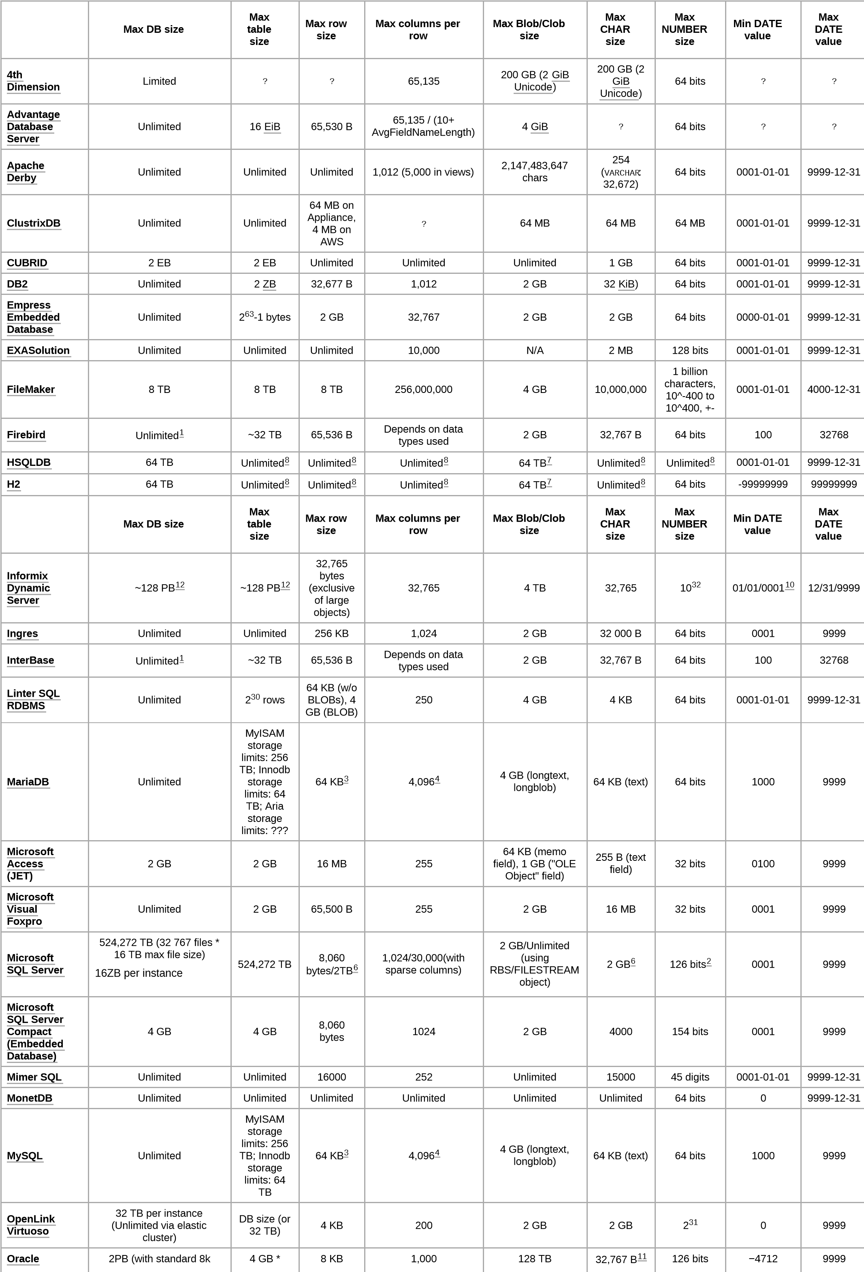

**Limites**

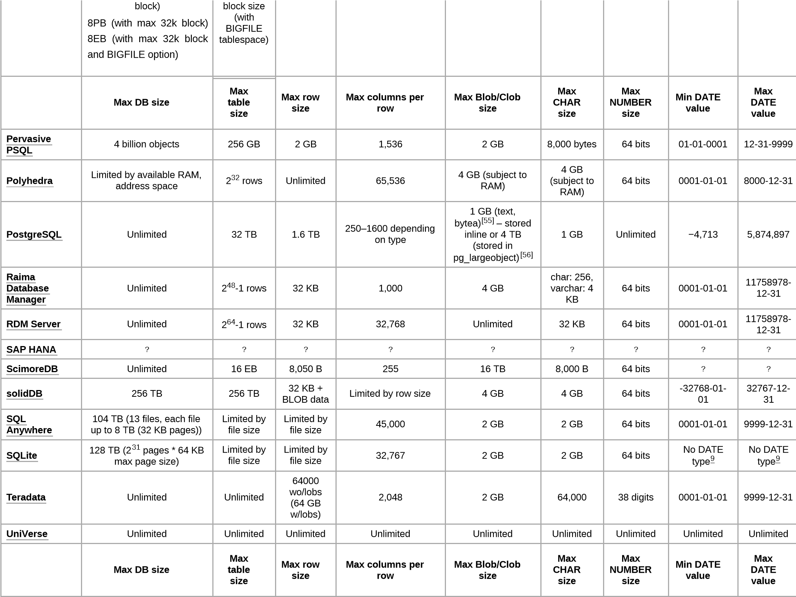

**Conclusión y justificación del uso de manejador PostgreSQL en nuestro proyecto.**

PostgresSQL es un manejador bajo la licencia PostgreSQL Licence (a liberal Open Source license), que nos permite hacer uso del servicio de manera gratuita. Y es importante ya que logra competir en funcionalidad y límites con los mejores sistemas bajo licencias propietarias.

Por otra parte su naturaleza multi-plataforma nos permite un nivel de adaptación del sistema que desarrollamos a cualquier otra plataforma cumpliendo el principio de extensibilidad.

Además es un sistema ideal para nuestro proyecto. Además los límites en el tamaño de una BD y en el tamaño de una tabla son extensos, corresponden a 32 TB y 1.6 TB respectivamente, que es excesivo para nuestro proyecto. Tiene un bloque a nivel de celda para ejecutar transacciones paralelamente.